Among the many attractions of Cuba, the vintage cars that still circulate today through its colorful streets, have a special place. Every possible part of most of the cars that have been in traffic since the 1950s or even 1940s, have been replaced in order to continue providing the service. It is not uncommon to meet great American classics from the Cadillac, Packard or Buick brands modified by parts from various other brands. This kind of "time travel" is very popular among the tourists in Havana. However, the authorities have not been concerned with preserving this heritage, despite the tourist possibilities it entails.
The old car museum, which was established to make up for this gap to some extent, looked more like a reservoir. Until the end of the first quarter of 2015, the old car museum was located on Oficios street where the Masjid is located today. Later, it was moved adjacent to the Mercado de Artesanos de Almacenes San José on Avenida del Puerto. In November 2019, the old car museum was reconfigured and reopened as Museo del Automóvil (El Garaje) in the picturesque historical center of Havana to mark the Habana 500 Anniversary celebrations. The restoration of the museum was sponsored by the Saudi Fund for Development in collaboration with Oficina del Historiador Ciudad de la Habana.
The museum consists of a small, renovated building in colonial style, made up of two large warehouses. In the bigger warehouse, a varied selection of classic cars from all eras were parked between tall cast iron columns on which the year of manufacture of the cars was written. However, the number of cars in the museum, which initially had about 50 different models of cars, motorcycles and gasoline pumps, gradually decreased, as some cars with historical characteristics were exhibited in other places, such as the Cadillac used by Ernesto Che Guevara when he was living in Havana, 1930 model Fiat used by Flor Loynaz and the 1959 model Oldsmobile used by Camilo Cienfuegos. Another reason is the frequent relocation of the museum in a short time. Today, less than 10 cars parked inside, dating mostly from the first half of the twentieth century, are on display, and the main warehouse where the cars were parked remains empty today.
When the museum was at its peak, its jewels were the 1926 model Rolls-Royce Phantom I Tourer by Letourneur et Marchand with a luxurious French bodywork, and the 1902 model Cadillac which was the oldest car in the collection. Unfortunately, they are not on the display currently; it is said that they are in the US for a through restoration, as the cars in the museum are maintained to prevent damage but are not restored. Other notable cars that are not on the display now, are a 1924 Dodge hearse by the Williams Carriage, Hearse & Auto Company of St. Louis, and a 1931 Cadillac V-16 Style 4275-C Imperial Landaulet with division window, one of two produced, owned by Alfredo Zayas, the former president of Cuba.
In the part of the museum that serves as the main exhibition, a fully restored Desoto Custom Convertible Coupe made in 1949, draws attention. It was donated by Dr. Eusebio Leal, the City Historian who received it as a gift from a wealthy US citizen, the Chicago collector Richard H. Driehaus for his initiating and leading the city's restoration efforts. On the walls, descriptive, graphic panels note historic highlights of Havana and Chicago, as well as the technical details of the car and the evolution of Desoto car.
A poster on the wall informs us the first cars that entered Cuna. "La Parisienne" is the first car introduced in Cuba by José Muñoz in 1898. With wick lanterns and gasoline as fuel, it reached a top speed of 12 km/h with a power of two horsepower. The second one is a Rochet and Shneider, built in Lyon and brought by the known businessman Ernesto Sarrá; it reached a speed of 30 km per hour and had eight horsepower.
A recreated 1915 Mack "Bulldog" stands in the closed part of the museum. Don’t forget that all cars in the museum are old, worn out and repaired with pieces here and there.

The 1981 Chevrolet donated by the Peruvian ambassador

Museo del Automovile is located on San Ignacio street #305-307-309, between Amargura y Teniente Rey streets in Old Havana.

The Museo del Automóvil (Automobile Museum) is located in a 1892 Neoclassical construction in Plaza de Armas Square, in Old Havana, Cuba.
This museum has a very well preserved and interesting collection of old automobiles, among which are the noteworthy Thunderbird, Pontiac, and Ford T, among others. It houses automobiles related to specific people and others and other antiquated vehicles.
San Ignacio e/ Teniente Rey y Amargura, La Habana, Cuba.
Ticket price:
1,5 CUP for Cuban citizens / 1,5 CUC for any other visitors.
Children up to 12: free admission.
Opening hours:
Tuesdays through Saturdays from 9.30am to 4.30pm, Sundays until 1.00pm

https://www.tripadvisor.it/Attraction_Review-g147271-d7789389-Reviews-Museo_Del_Automovil-Havana_Ciudad_de_la_Habana_Province_Cuba.html

Just like on the streets, don't expect pristine chrome or shiny paint; all the vehicles in this museum are old, worn out and repaired with pieces here and there.

In keeping with the above are another 1932 Cadillac and a 1929 Packard Eight, a 1950s MG TD, all kinds of 1920s to 1950s American classics with multiple modifications, a 1960s Alfa Romeo Spider or an impressive, relatively well-preserved 1920s Mack truck.
At the bottom of one of the ships there is a strange little car with captivating Maserati logos, which is nothing more than a 1/2 scale model that was used in a film shot in Havana about the races that Fangio raced there at the controls of a real Maserati in the 1950s.
Behind this "pretend car" You can see many other wrecked cars that are stored there but can only be "glimpsed", and if we look closely we will discover interesting things like a 1950s Mercedes 190 SL or an impressive 1920s Packard Phaeton.
Of course, as is the case on the streets, don't expect immaculate chrome or shiny paint; All the vehicles in this museum are old, worn and repaired with parts here and there, a situation that we hope will improve in the near future, as these little gems definitely deserve it.

he Depósito del Automóvil (automobile depository) is a museum in the Old Havana section of Havana, Cuba. It consists of a small building made up of two large rooms. The cars are maintained to prevent damage but are not restored.
Address: Calle Oficios No. 12 y Callejón de Jústiz. La Habana Vieja. Ciudad de La Habana.

List of cars[edit]
- 1926 Rolls-Royce Phantom I
- 1953 MG TD
- 1920s Fiat
- Alfa Romeo roadster
- 1970s Daimler
- 1980s Chevy
- replica of a 1957 Maserati used by Juan Manuel Fangio
- Cadillac V16 1930
- 1959 Oldsmobile, owned by Commander Camilo Cienfuegos
- 1918 Ford T
- 1930 Baby Lincoln
- 1969 Citroën Méhari
- funeral carriage

List of Motor Bikes[edit]
- 1977 Ducati 900SS owned by Fidel Castro

List of Trucks[edit]
- 1915 Mack AC. Chain drive 3.5 ton, 4-cylinder, 4 gears

Other Exhibits[edit]
- 3 fuel pumps
- a semaphore
- HAVANA TIMES – Walking down San Ignacio Street in Old Havana last Saturday, I came across a car museum, which has only been open for the past eight months.
- There, I could appreciate the history of Cuba’s automobile industry from the very first Ford model T manufactured in 1914, to a jet ski made today.
- However, the thing that really caught my attention was a special room where there was a car donated to the museum by Eusebio Leal, the City Historian. This had in turn been a gift to our historian from a wealthy US citizen. It’s a 1949 DeSoto, a real gem of engineering and design, with 0 km on the odometer.
- I recommend you take a trip back in time to when classic cars first arrived in Havana.
- The museum is open from Tuesday to Saturday from 9:30 AM to 3 PM, and Sundays from 9:30 AM until noon. Have a good trip back in time! Address: Calle San Ignacio e/ Amargura y Teniente Rey, Old Havana.

https://havanatimes.org/features/a-new-classic-car-museum-in-old-havana/

The Havana Automobile Museum, "El Garaje", is located on San Ignacio street, between Amargura and Teniente Rey, in the Historic Center of the city, where the most relevant automobiles of the first half of the 20th century in Cuba are exhibited.
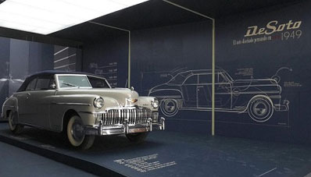
car desoto
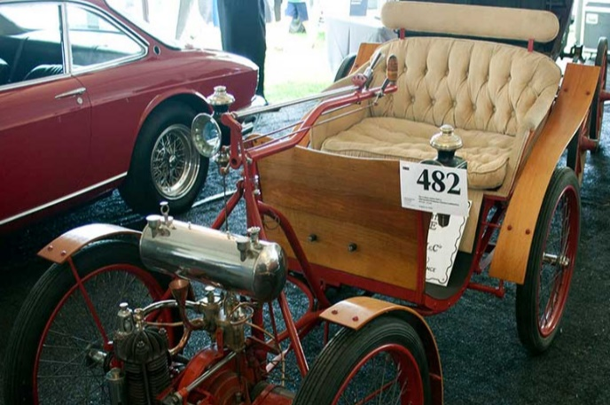
First automobile in Cuba
On the walls of the enclosure hangs a poster that explains what "La Parisienne" was, the first car introduced in Cuba in 1898 by José Muñoz. With wick lanterns and gasoline as fuel, it reached a top speed of 12 km/h with a power of two horsepower.
The second came in 1899 and it was thanks to the well-known businessman Ernesto Sarrá. It was a Rochet and Shneider built in Lyon, which reached a speed of 30 km per hour and had eight horsepower.
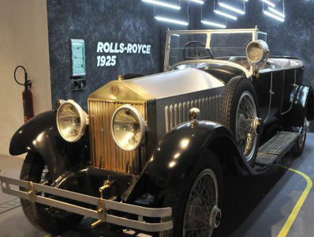
rolls royce museum
Accompanied by photographs of these cars, the poster also talks about the opening of the first garage workshop, where the name of fotingo comes from, the most representative brands, the model that introduced the first safe automatic transmission and an explanation of the La Macorina car, the first woman to drive a car in Cuba .
When visiting the installation we find a Rolls Royce from 1925, a true collector's jewel, where visitors to the museum enjoy taking as a record in their photos. Also a 1933 Packard, a model similar to the one used by the famous Chicago gangster al Capone. In Varadero, in the house that used to belong to Al Capone, today a restaurant, there is a concrete monument.
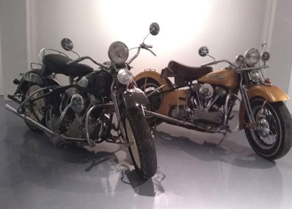
motorcycle museum
The main room shows a very important part of the collection, nine cars very different from each other make up the sample. The oldest of all dates from 1914.
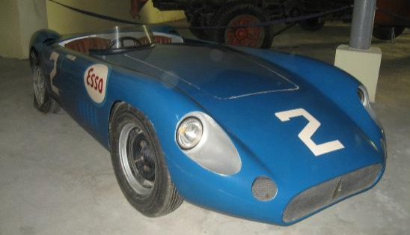
masserati museum
In 1958, Cuba held the sixth place in the world in number of vehicles per inhabitant. And it was during this time that the automotive fleet that represents the majority of the classic vehicles that today roll around the country began to circulate.
Fully reopened as part of the activities for the 501st anniversary of the founding of the town of San Cristóbal de La Habana, among other classics of great heritage value, cars such as the Masserati similar to the legendary Juan Manuel Fangio that he would use for the Havana Grand Prix in 1957.
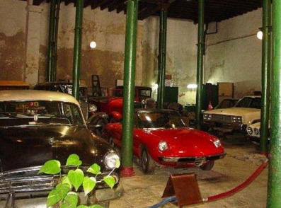
alfa romeo museum
He is accompanied by cars of important personalities in the history of Cuba, an OLDSMOBILE from 1960 that belonged to the unforgettable Celia Sánchez; and a beautiful Alfa Romeo, where the Havana Carnival Queen used to walk.
Vehicles donated by various institutions such as a 1980 Limousine and a 1989 Jaguar by the British Embassy are included.
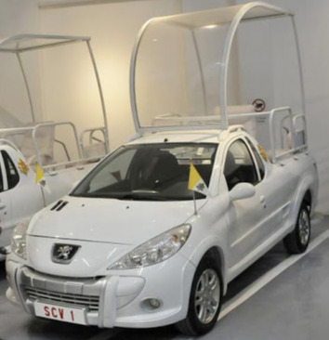
popemobile museum
This parking lot is filled with the three Popemobiles in which Pope Francis traveled during his visit to the Caribbean nation through the cities of Havana, Santiago de Cuba and Holguín in 2014.
Cuba is one of the countries that treasures the most classic cars, in any corner of the country there are old vehicles that contribute to making our country a mobile museum. (Internet compilation)

https://forums.aaca.org/topic/367176-museo-del-autom%C3%B3vil-el-garaje-havana-cuba/

https://www.facebook.com/museodelautomovilohch/?ref=page_internal

Among the many attractions of Cuba, the vintage cars that still circulate today through its colorful streets, have a special place. Every possible part of most of the cars that have been in traffic since the 1950s or even 1940s, have been replaced in order to continue providing the service. It is not uncommon to meet great American classics from the Cadillac, Packard or Buick brands modified by parts from various other brands. This kind of "time travel" is very popular among the tourists in Havana. However, the authorities have not been concerned with preserving this heritage, despite the tourist possibilities it entails.
The old car museum, which was established to make up for this gap to some extent, looked more like a reservoir. Until the end of the first quarter of 2015, the old car museum was located on Oficios street where the Masjid is located today. Later, it was moved adjacent to the Mercado de Artesanos de Almacenes San José on Avenida del Puerto. In November 2019, the old car museum was reconfigured and reopened as Museo del Automóvil (El Garaje) in the picturesque historical center of Havana to mark the Habana 500 Anniversary celebrations. The restoration of the museum was sponsored by the Saudi Fund for Development in collaboration with Oficina del Historiador Ciudad de la Habana. However, it took until early 2024 for the museum to begin displaying its entire motor vehicle collection.
The museum consists of a small, renovated building in colonial style, made up of two large warehouses. In the bigger warehouse, a varied selection of classic cars from all eras were parked between tall cast iron columns on which the year of manufacture of the cars was written. However, the number of cars in the museum, which initially had about 50 different models of cars, motorcycles and gasoline pumps, gradually decreased, as some cars with historical characteristics were exhibited in other places, such as the Cadillac used by Ernesto Che Guevara when he was living in Havana and 1930 model Fiat used by Flor Loynaz Another reason is the frequent relocation of the museum in a short time. Today, less than 30 cars parked inside, dating mostly from the first half of the twentieth century, are on display.
When the museum was at its peak, its jewels was the 1926 model Rolls-Royce Phantom I Tourer by Letourneur et Marchand with a luxurious French bodywork, Unfortunately, it is not on the display currently; it is said that it is in the US for a through restoration, as the cars in the museum are maintained to prevent damage but are not restored. Other notable cars that are not on the display now, are a 1924 Dodge hearse by the Williams Carriage, Hearse & Auto Company of St. Louis, and a 1931 Cadillac V-16 Style 4275-C Imperial Landaulet with division window, one of two produced, owned by Alfredo Zayas, the former president of Cuba.
The museum has two floors. While cars, gas pumps and traffic lights are exhibited on the first floor, motorcycles and a jet ski are exhibited on the upper floor. There is also a rich collection of miniature cars on the upper floor. The lower floor consists of two separate exhibition areas with a slight slope and a difference in level. The cars in the museum are listed according to their production dates. There are signs detailing the technical features of each car. If that car has a historical feature, these are also included on the sign.
A poster on the wall informs us the first cars that entered Cuna. La Parisienne is the first car introduced in Cuba by José Muñoz in 1898. With wick lanterns and gasoline as fuel, it reached a top speed of 12 km/h with a power of two horsepower. The second one is a Rochet and Schneider, built in Lyon and brought by the known businessman Ernesto Sarrá; it reached a speed of 30 km per hour and had eight horsepower.
The 1902 model Cadillac is the oldest car in the collection. In addition to this, the museum features many cars of particular interest. These include a 1925 Rolls Royce (Model Phantom); a 1959 Oldsmobile (Model 98) that belonged to Camilo Cienfuegos; a 1960 Oldsmobile (Model Super 88), owned by the revolutionary Celia Sánchez Manduley; a 2011 Peugeot with bulletproof glass cabins used during the visit of Pope Francis (Benedict XVI) to Cuba in 2015 (Model Hoggar); a fully restored 1949 Desoto Custom Convertible Coupe made in 1949, donated by Dr. Eusebio Leal, the City Historian who received it as a gift from a wealthy US citizen, the Chicago collector Richard H. Driehaus for his initiating and leading the city's restoration efforts; a recreated 1915 Mack "Bulldog; a handcrafted 1909 Ford Roadster, which was built by a Cuban craftsman in the 1940s for recreational use; Fords (Model T) made in 1914 and 1918; and Fords (Model A) made in 1928 and 1931. However, the most questioned reason for its presence in the museum is the 1957 Maserati displayed upright in the air. The interesting story about this is given on the side.
Among the many Harley-Davidson motorcycles, the most interesting vehicle on the top floor is the 1977 Ducati 900SS DESMO motor bike, owned by Fidel Castro.

