Capiro Hill is a place worth considering both for its geographical location, as one the highest point around the city of Santa Clara, overlooking the entire city, and for its strategic importance in the Battle of Santa Clara, which played a critical role in the victory of the Revolution. Loma del Capiro is the symbol of the struggle between patriots with much less opportunity against the powerful oppressor, crowned with the victory of the patriots.
The hill was named after its former owner, Cristóbal de Moya, a native of Santa Clara. During a visit to Panama, Cristóbal noticed that Monte Capiro in Portolebo was very similar to the one he owned. Upon his return from the trip, he gave the same name to the hill in Santa Clara.
The site was declared a National Monument in 1990, along with the Armored Train.
Geographical Significance
Loma del Capiro is a geological formation located in Cretaceous-Tertiary time. It is part of the Loma del Capiro Historic-Cultural Park which also includes the neighboring twin hills known as Dos Hermanas (Two Sisters). With its height of 176,5 meters, Capiro Hill is the smallest among the three elevations constituting a whole. The neighboring hills (Dos Hermanas) are 185,9 and 188,4 meters above the sea level.
Dos Hermanas is known in scientific circles due to the discovery of abundant evidence of the Chicxulub meteorite impacting Earth on its slopes. The Chicxulub impact refers to a massive meteor that struck the Yucatán Peninsula during the Cretaceous/Paleogene period and is believed to have played a significant role in the mass extinction of the dinosaurs millions of years ago by generating horrific mega tsunamis, earthquakes, and storms which modeled the Antillean archipelago. Cuba was particularly affected by the island's proximity and its elongated structure.
Historical Significance
Capiro Hill was a strategic point that played a role in the victory over Batista's army in the Battle of Santa Clara. On December 28, 1958, forces under the command of Che Guevara (approximately 300 poorly armed guerrillas) launched a campaign to capture Santa Clara, defended by approximately 3,000 army personnel, and to prevent the passage of a train carrying weapons and ammunition to the east of the island. Batista’s troops stationed in Santa Clara was supported by the air force, an armored train, artillery, machine guns, and dozens of armored units. They also held all the city's high points and strategic positions. Given this disparity in military forces, Che Guevara adopted a different tactic, and made a plan to first capture Capiro Hill, the highest point of the city, and in the second stage to disable the armored train loaded with weapons, and then attack the city.
Thus, the first attack was launched against a group of soldiers from an armored train which were positioned in the trenches on the southern slope of the hill. A platoon under the command of Luis Alfonso Zayas and a part of the Suicide Platoon under the command of Lieutenant Hugo del Río advanced towards this area on the hill. However, they encountered intense mortar and heavy-caliber gunfire. They were also attacked from the air. The rebels fought all day on the first day of the attack (December 28, 1958) and managed to surrender the hill in the early morning hours of December 29.
After the capture of the Capiro Hill Che Guevara ordered several members of the Suicide Platoon to join the main group of rebels as they attacked toward the center of Santa Clara. He also ordered a small detachment under the command of Luis Alfonso Zayas to capture soldiers who had escaped or lost their way from the forces at Loma del Capiro.
The retreating soldiers made their way to the armored train, but shortly thereafter, the train was derailed by the rebels, and the railway was destroyed. After a brief clash, all soldiers in the area, including Colonel Casillas Lumpuy, surrendered, and the rebels advanced with all their might toward the city center of Santa Clara. It is said that Che led the attack from here in the period between the capture of the hill and the fall of Santa Clara (approximately 24 hours).
Touristic Significance
Capiro Hill is a popular destination for both locals and tourists, even except certain day of celebrations. It is a vantage point for the extraordinary beauty of the Santa Clara Valley and provides stunning panoramic views of the city.
The peak is reached by a winding, moderately steep, step-paved road. You have to climb approximately 200 steps to reach the peak.
At the peak stands the metallic Monument to the Battle of Santa Clara. It is the work of the sculptor José Delarra and erected in 1988. The monument consists of weapons of various calibers pointed at the sky, surrounded by a ring. A silhouette of Che Guevara is depicted on the ring. The monument rests on a green marble base. The sculpture represents the defense of the nation's skies and symbolizes the will to unite the Cuban nation. The peak is marked by two flags.
You can see the trenches around, dug by rebel forces surround the monument.
On the southern slope of the hill, there is a tamarind plantation that has been preserved and expanded for several decades. This is the symbolic tree of the city of Santa Clara and represents its founding. Every July 16th, a tamarind tree is planted there during a solemn ceremony.
The surrounding lands of the hill have long been a supplier of fruits, herbs, medicinal products, vegetables and other products.

Monument to the Holy Father, John Paul II
A few meters away, on an esplanade, the papal mass of the Holy Father John Paul II was celebrated during his visit to the city on January 22, 1998. This memorable encounter is commemorated on the site with the Monument to Pope John Paul II, erected by the Catholic Church in agreement with the city government on its tenth anniversary; it was inaugurated on February 23, 2008, and is the first religious statue erected in Cuba outside of a church.

Loma del Capiro . A natural elevation in the Cuban city of Santa Clara , which, due to its strategic location, was captured by the troops of Commander Ernesto Guevara de la Serna during the battle that would immortalize the capital of Villa Clara province . A National Monument of the Republic of Cuba since 1990, its summit features a sculpture by José Delarra, recently escorted by huge Cuban and July 26th flags. It is part of the Loma del Capiro Historical-Cultural Park, which also includes the neighboring elevation known as "Dos Hermanas", where significant evidence of the impact of the famous Chicxulub meteorite that wiped out the dinosaurs was found years ago.

Oronymy
The name "Capiro," by which the historic elevation is known, was given by Cristóbal de Moya, former owner of the land where it is located, due to its resemblance to a mountain of the same name he had visited among the hills surrounding the Panamanian city of Portobelo . The event is recorded in the surviving writings of two of the trip's participants.

Physical-geographical characteristics
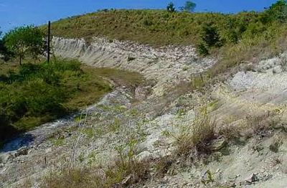
Cretaceous-Tertiary boundary (LKT) discovered on the "Dos Hermanas" hill, adjacent to Capiro, where abundant evidence of the Chicxulub meteorite was found at the beginning of the century .
El Capiro is part of a two-mountain system, the lowest of which, at 176.5 meters above sea level, is the highest. Its neighbor, known as "Dos Hermanas," with elevations of 185.9 and 188.4 meters above sea level, would become particularly notable in the scientific field due to the appearance on its slopes of significant evidence of the Chicxulub meteorite , which caused the mass extinction of the dinosaurs millions of years ago. The impact, which would generate horrific tsunamis, earthquakes, and storms, would significantly affect Cuba, given its proximity to Yucatán. Due to its location, the elevation offers magnificent views of the city, while also possessing notable scenic value given its stark contrast within the urban context, also providing its inhabitants with fruits, medicinal plants, vegetables, and other goods.
- 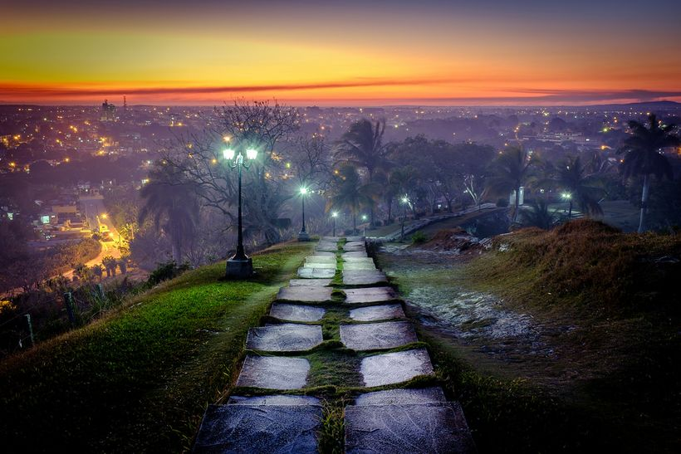
Sunset in the city of Santa Clara seen from Capiro Hill.

Historical importance
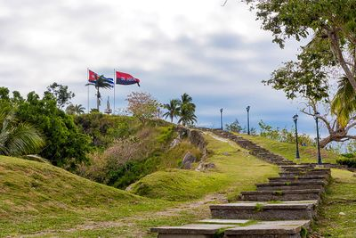
Staircase leading to the top of Capiro hill
Capiro Hill was a strategic point in the Battle of Santa Clara and in the rebel army's victory in the 1959 liberation war . On December 28, 1958 , the men of the column commanded by Che Guevara undertook a series of armed actions to prevent the passage of reinforcements to eastern Cuba, especially those of an armored train carrying weapons and troops ready to act under the orders of Colonel Casillas Lumpuy , who had assassinated sugar mill leader Jesús Menéndez years before and was in Santa Clara at the head of the Leoncio Vidal Regiment . The total number of soldiers stationed in Santa Clara to halt the rebel attack numbered 3,500, supported by the air force, an armored train, artillery, machine guns, and dozens of armored units; they also occupied all the high points and strategic positions in the city. The forces under Che Guevara's command numbered barely 400 poorly armed guerrillas. In the heat of battle and faced with such a difference in strength, Che made important tactical decisions.
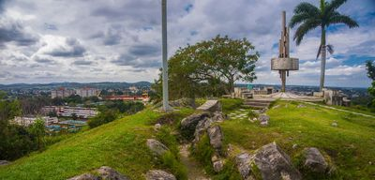
Monument located at the top of Capiro. The image shows the trenches from which soldiers during Fulgencio Batista's dictatorship fired on the city until the hill was captured by troops commanded by Ernesto Guevara.
The first act of war was to attack "Loma del Capiro," where a group of enemy troops from the Armored Train stationed on its southern slope were entrenched. A platoon under the command of Luis Alfonso Zayas and part of the Suicide Platoon under the command of Lieutenant Hugo del Río advanced toward the hill . They were met with mortar and heavy-caliber weapons fire, combined with air harassment. They fought all day on the 28th, and in the early hours of December 29 , 1958 , they managed to surrender the city. Che Guevara led the few members of the Suicide Platoon out of the hill and ordered them to advance toward the city, but not before leaving one rebel, Antonio Pérez González , dead , another wounded, and several stunned by the explosion of the shells. He also instructed Zayas to have his small platoon hold off the soldiers who had been cut off from the rest of the forces on Loma del Capiro. The evacuated troops retreated toward the Armored Train , which derailed minutes later because the rebels had destroyed the railway lines; after a short battle, it was forced to surrender. A few hours later, after intense fighting, the city was captured, Colonel Casillas Lumpuy was captured, Batista fled the country, and the Cuban Revolution triumphed.
- 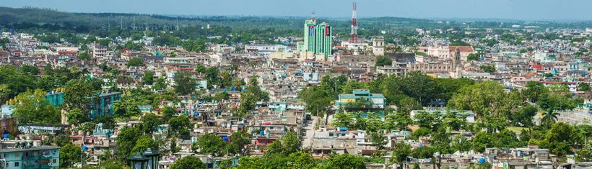
View of downtown Santa Clara from Capiro, a strategic enclave of the tyranny that was captured by the Rebel Army during the battle that would immortalize the city. In the center of the image, the former Grand Hilton Hotel, now Santa Clara Libre .

Monuments and historical sites
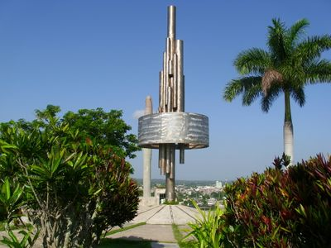
Monument of José Delarra on the Capiro hill.
- Monument to the Battle of Santa Clara
At the top of the hill, a monument was placed by sculptor José Delarra in 1988. It represents the union of different calibers of firearms projected toward the sky, joined by a ring. The sculpture represents the defense of the nation's skies and rests on a marble base. The site was declared a National Monument of the Republic of Cuba on January 30, 1990 , along with the Armored Train .
- Tamarind forest
On the southern slope, there is a tamarind plantation that has been preserved and expanded for several decades. This is the symbolic tree of the city of Santa Clara and represents its founding. Every July 16th, a tamarind tree is planted there in a solemn ceremony in the presence of government and community authorities.
- Monument to the Holy Father, John Paul II
A few meters away, on an esplanade, the papal mass of the Holy Father John Paul II was celebrated during his visit to the city on January 22 , 1998. This memorable encounter is commemorated on the site with the Monument to Pope John Paul II , erected by the Catholic Church in agreement with the city government on its tenth anniversary; it was inaugurated on February 23, 2008 , and is the first religious statue erected in Cuba outside of a church.
- 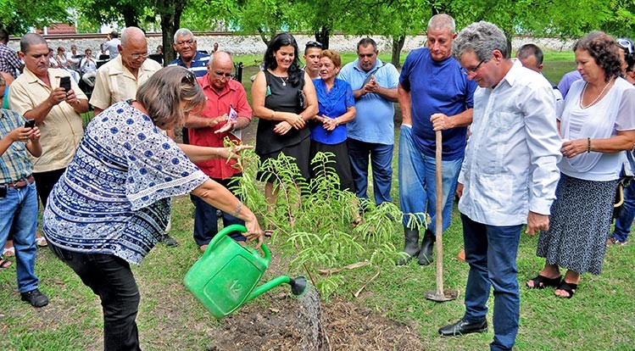
Planting of a tamarind tree on the 327th anniversary of Santa Clara. A founding symbol of Villa Clara, since 1989, the year in which the city's 300th anniversary was commemorated, the tamarind forest has been known as the "tamarind forest" on the southern slope of Capiro.

