5 Monumento a la Toma del Tren Blindado

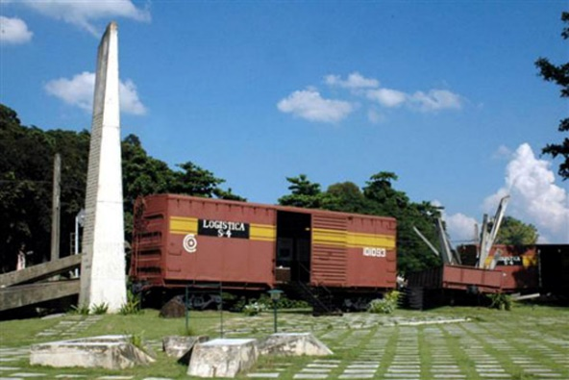

History was made at the site of this small boxcar museum on December 29, 1958, when Ernesto 'Che' Guevara and a band of 18 rifle-wielding revolutionaries barely out of their teens derailed an armored train using a borrowed bulldozer and homemade Molotov cocktails.
The battle lasted 90 minutes and improbably pulled the rug out from under the Batista dictatorship, ushering in 50 years of Fidel Castro. The museum – east on Independencia, just over the river – marks the spot where the train derailed and ejected its 350 heavily armed government troops. The celebrated bulldozer is mounted on its own plinth at the entrance.
https://www.ecured.cu/Monumento_al_Asalto_al_Tren_Blindado

Monument to the Assault on the Armored Train

Monumento al Asalto al Tren Blindado

The Freight Car Museum with the Monument to the Assault on the Armored Train is located at the northern entrance to the city, on the road to Camajuaní between the La Cruz bridge and the railway line.
Tuesday – Saturday 09:00 -17:30, Sunday 24 hours, Monday closed
<iframe src="https://www.google.com/maps/embed?pb=!1m18!1m12!1m3!1d3688.5098703939807!2d-79.960537996261!3d22.409827333567613!2m3!1f0!2f0!3f0!3m2!1i1024!2i768!4f13.1!3m3!1m2!1s0x88d52e7c44311e8d%3A0x67e9dd64d3a841c3!2sTaking%20of%20the%20Armored%20Train!5e0!3m2!1str!2str!4v1754725739263!5m2!1str!2str" width="600" height="450" style="border:0;" allowfullscreen="" loading="lazy" referrerpolicy="no-referrer-when-downgrade"></iframe>

Monument to the Assault on the Armored Train
The Battle of Santa Clara was the most crucial stage in the victory of the Revolution in Cuba. The rebels, in an attempt to infiltrate the west, took complete control of Villa Clara in just three days, opening the way to Havana. The capture of the region, as well as the detention of a train in Santa Clara, loaded with weapons, ammunition, and military supplies which were desperately needed by the capital, were decisive in the end of the Batista regime. This military victory is commemorated with a Freight Car Museum in the spot where the armored train was derailed.

Receiving intelligence that a train loaded with military ammunition was in Santa Clara on its way to Havana, Che Guevara instructed Captain Ramón Pardo Guerra Guile to seize the train on December 28, 1958. With Che Guevara's own participation, an 18-man detachment under the command of Ramón Pardo, belonging to the Ciro Redondo Column, attacked the train consisting of two locomotives and 18 cars at what is now an open-air museum (Freight Car Museum). Using a borrowed bulldozer, the train was derailed. The rebels had only rifles and homemade Molotov cocktails. The train, however, had 408 officers and soldiers, and it was loaded with powerful weapons, including cannons, bazookas, rocket launchers, machine guns of various calibers, rifles, and abundant ammunition.
After a firefight lasting about 1,5 hours, Batista's soldiers surrendered, and all the military ammunition, along with the train, was seized, depriving Batista’s army of reinforcements.
This brilliant military victory of the rebels led Batista to realize the end was near. He fled to the Dominican Republic without waiting for the fall of Santa Clara at dawn on January 1, 1959. Revolutionary forces under his command of Fidel Castro and Camillo Cienfuegos entered Havana on January 8, 1959, seized control, and declared the victory of the revolution.

It was decided to erect a monument to commemorate this historic military victory, and to transform the area where the train was captured into an open-air museum.
The initial artistic design for this museum which was called Freight Car Museum, was created by artist Ramón Rodríguez Limonte, and the first monument was unveiled on December 29, 1971.
The open-air museum was officially opened on July 13, 1987, after renowned sculptor José Delarra completed its final design, placing wagons on the museum grounds.
In the years following this date, the museum was enriched by the addition of the original bulldozer that Che used to lift the railway lines and cause derailment, and the carriage that was placed to convey the impression of movement.
The permanent exhibitions inside the wagons feature historical documents, weapons, photographs, and objects related to the military operation.

- Freight Car Museum Hours: Monday to Saturday, 8:30 a.m. to 5:30 p.m. ^{[2]}
- Entrance fee to the Freight Car Museum: 1 CUC . ^{[2]}

El 28 de diciembre de 1958 un peloton de 18 hombres de la Columna "Ciro Redondo", al mando del Capitan Ramon Pardo Guerra Guile bajo las ordenes del Comandante Ernesto Che Guevara y con su participacion directa descarrilo, ataco y tomo un tren blindado compuesto por 2 locomotoras y 18 carros, con una dotacion de 408 hombres entre oficiales y soldados y un poderoso armamento que incluia canones, bazookas, lanza-cohetes, ametralladoras de diversos calbres, fusiles y abundante parque.
En hora y media de combate los soldados del Ejercito Rebelde, solo con fusiles y Botellas incendiarias, lograron la rendicion del enemigo y alcanzaron una brillante victoria militar.
Gloria a los Heroes

On December 28, 1958, an 18-man platoon from the "Ciro Redondo" Column, commanded by Captain Ramón Pardo Guerra Guile, under the orders of Commander Ernesto Che Guevara and with his direct participation, derailed, attacked, and captured an armored train consisting of two locomotives and 18 cars, with a complement of 408 officers and enlisted men, and powerful weapons that included cannons, bazookas, rocket launchers, machine guns of various calibers, rifles, and abundant ammunition.
In an hour and a half of combat, the Rebel Army soldiers, armed only with rifles and incendiary canisters, achieved the enemy's surrender and achieved a brilliant military victory.

The Monument to the Assault on the Armored Train is located in the city of Santa Clara (in central Cuba), in commemoration of one of the most important actions fought by the Rebel Army led by Commander Ernesto Che Guevara on December 29 , 1958. [ ^{1]}
The monument is located east of Vidal Park, on the road to Camajuaní between the La Cruz bridge and the railway line. ^{[2]}
A few blocks east of the Armored Train, the Che with Child statue shows the commander with a baby, symbolizing the next generation. ^{[2]}

Summary
- 1 The action in 1958
- 2 Monument data
- 3 The monument's wagons
- 4 Visitors
- 5 Sources

The action in 1958
Ernesto Che Guevara and a group of young revolutionaries derailed an armored train using a borrowed bulldozer and homemade Molotov cocktails.
It marked the end of the Batista dictatorship and paved the way for the triumph of the Cuban Revolution (on January 1, 1959).
The event is commemorated with a Freight Car Museum across the river, marking the spot where the train derailed and the 350 heavily armed Batista soldiers were thrown into. The famous bulldozer also has its own memorial there. ^{[2]}
The heroic action thwarted the dictatorship's plan to reinforce the eastern provinces, an outbreak represented by a group of columns of different sizes and shapes that stopped the train.

Monument data
- Director of the institution: Violeta Delgado Torrecilla.
- 1971 (December 29): The first monument was inaugurated, under the direction of the Villa Clara artist Ramón Rodríguez Limonte (1942-). ^{[3]}
- 1987 (July 13): The current monument is inaugurated, by the late creator of the plastic arts José Delarra (1938-2003). ^{[4]}
- The monument was later enriched by the carriages—placed to convey the impression of movement—and the incorporation of the original bulldozer that Che used to lift the railway lines and cause the derailment, assault, and seizure of the convoy loaded with ammunition, weapons, and Batista soldiers.
- Freight Car Museum Hours: Monday to Saturday, 8:30 a.m. to 5:30 p.m. ^{[2]}
- Entrance fee to the Freight Car Museum: 1 CUC . ^{[2]}
Architect(s): | Ramón Rodríguez Limonte (original idea);  José Delarra ;  later enriched with wagons

The monument's wagons
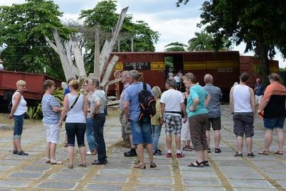
Members of the May Day Solidarity with Cuba Brigade during a tour of the monument.
The wagons are used as permanent exhibits, displaying objects, photos, and documents, as well as weapons similar to those carried by the dictatorship's forces. Banners explain what happened during the important maneuver conceived by Commander Che Guevara.
...one of the cars reflects the journey of the invading column number eight Ciro Redondo , from its arrival in the hills of the former province of Las Villas , on October 16, 1958, until the liberation of the towns in the central territory, which concludes with the battle of Santa Clara .
Violeta Delgado Torrecilla, director of the institution

Visitors
- This national monument of the Republic of Cuba receives hundreds of visitors daily.
- In the six-month period from January to June 2017, it received a cumulative total of 115,374 visitors.
- The attendees come from different parts of the world, interested in the figure of the Heroic Guerrilla (Ernesto Che Guevara) and his participation in the fight to overthrow the old regime, and are amazed by knowing the reality of Cuba and his determination to carry forward the work of the Revolution. ^{[5]}

Standing in front of the Provincial headquarters of the Communist Party of Cuba, the life-size statue of Ernesto Che Guevara points to future generations with the child he carries in his left arm. The statue, which commemorates the 35th anniversary of Ernesto Che Guevara's death, was made by the Basque artist Castro Solana.
Avenida Liberación

It took eleven months of that same year to cast the Che sculpture in bronze

